Module 04 Activity – Writing Conditional Statements

Tracy Brevig

Rasmussen College

COURSE#: W110/COP1801 Section 01 Javascript

Instructor’s Name: Kimberly Powell

March 7, 2021

**Screenshots of the loaded pages:**

**Prompts user for three numbers.**

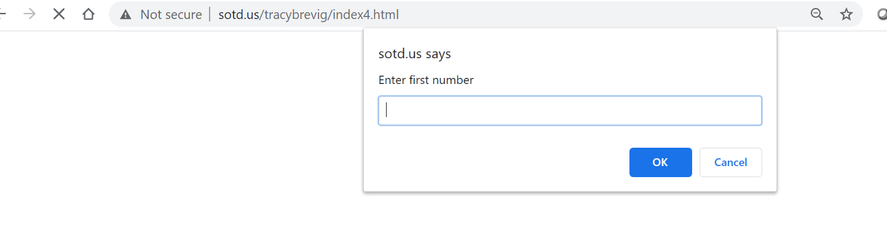

**Then Displays the numbers in sorted order:**

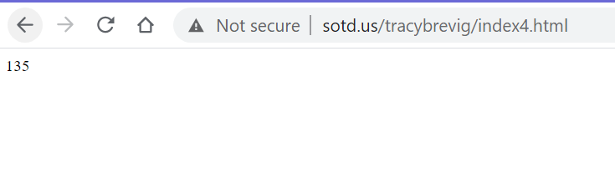

URL Link

<http://sotd.us/tracybrevig/index4.html>